

TCS BFSI Research & Innovation

Automated Regulatory Compliance Solution (ARC)-2.0

Installation Manual

June, 2022

Notice
© 2021 Tata Consultancy Services Limited
This is a controlled document. Unauthorized access, copying, replication or usage for a purpose other than for which it is intended, are prohibited.
All trademarks that appear in the document have been used for identification purposes only and belong to their respective companies.

Document Revision List

Rev No. | Revision Date | Revision Description | Release Notice  Reference
0.1 | 09/July/2021 | Initial Version | NA
0.2 | 05/August/2021 | Modified software version | NA

The documents or revised pages are subject to document control.
Please keep them up-to-date using the release notices from the distributor of the document.
These are confidential documents. Unauthorized access or copying is prohibited.

Approved by : V V Anil Kumar Velichaty Authorized by : Vijayaraghavan Venkataraman
Date : 05 August 2021 Date : 05 August 2021

About this Manual

Purpose
This manual has been written to help you setup Automated Regulatory Compliance Solution (ARC) application.

Intended Audience
This manual is primarily intended for system administrators who will be responsible for configuring and maintaining ARC application.

Prerequisites for Use
Functional – Basic understanding of risk and compliance related areas is required.
Technical - Basic understanding of Windows and GUI operations is required.

Related Documentation
Automated Regulatory Compliance Solution (ARC)-1.0 User Manual

Organisation of the Manual
This manual is organised as follows:

Table 1: Organization of the Document

Chapter | Description
1 | Introduction
2 | Pre-Installation
3 | Installation
4 | Un-Installation

Contents
Document Revision List 3
About this Manual 4
Purpose 4
Intended Audience 4
Prerequisites for Use 4
Related Documentation 4
Organisation of the Manual 4
List of Tables 6
List of Abbreviations 6
1. Introduction 7
2. Pre-Installation Tasks 7
2.1 Software requirement 7
2.2 Hardware requirement 7
2.3 Install mod_wsgi on Windows 8
2.4 Install mod_wsgi on Linux 8
2.5 Install Python packages 8
2.6 Apache HTTPD Configurations 9
2.7 Configure Keycloak with PostgreSQL Database 9
2.8 Configure Keycloak with ARC realm 13
3. Installation Procedure 22
3.1 Keystore setup 22
3.2 Update config files 23
3.3 Install UI Module 24
3.4 Install Python services 24
4. Un-Installation Procedure 24
About Tata Consultancy Services Ltd (TCS) 25

List of Tables

Table 1: Organization of the Document 4
Table 2: Software Requirement 8
Table 3: Hardware Requirement 8

List of Abbreviations

Abbreviation/ Acronym | Expansion
API | Application Programming Interface
CPU | Central Processing Unit
DB | Database
GB | Giga Byte
JDK | Java Development Kit
J2EE | Java 2 Platform, Enterprise Edition
RDBMS | Relational Database Management
ARC | Automated Regulatory Compliance Solution
SSO | Single Sign On
UI | User Interface
URL | Uniform Resource Locator
VM | Virtual Machine

- Introduction
Automated Regulatory Compliance Solution (ARC) is a smart compliance hub, that could enable intelligent intervention to address key regulatory compliance challenges and improve compliance hygiene/ compliance management. Smart compliance (ARC), powered by TCS Machine First Delivery Model (MFDM) would enable Financial Institutions to deliver the following business objectives.

- Ontology based design frameworks - Develop knowledge modeling of regulations or policies or controls.
- Obligation Extraction - Leveraging knowledge models, drive intelligent extractions of obligations for the regulations.
- Lineage Assessment - Leveraging knowledge models, assess and create lineage to organizational internal controls/policies environment.

- Pre-Installation Tasks
  - Software requirement
Table 2: Software Requirement
Application Sub-System | Software and Version No | Usage
UI & Cognitive | Apache httpd 2.4.53 | Used for deployment of UI components
Core Services | JRE 11.0.2 | Required for Running Java Packages
Core Services | RDBMS (PostgreSQL 13.6) | Used as DB
Cognitive Services | Python 3.8.5 | Required for Running python Packages
Operating System | CentOS 7 | OS
Core Services | Keycloak 13+ (latest) | User management

  - Hardware requirement
A typical hardware sizing for development and testing environment without HA is as below.

Table 3: Hardware Requirement
Hardware Type | Vendor - Model | Specification | Qty
Database Server | Blade/VM | CPU: 4 Core 2.5 GHz+, Memory: 16 GB, Disk: 100 GB | 1
Application Server | Blade/VM | CPU: 4 Core 2.5 GHz+, Memory: 16 GB, Disk: 100 GB | 2
Web Server | Blade/VM | CPU: 4 Core 2.5 GHz+, Memory: 8 GB, Disk: 100 GB | 1
  - Install mod_wsgi on Windows
Get relevant version of mod_wsgi wheel from https://www.lfd.uci.edu/~gohlke/pythonlibs/#mod_wsgi
1. Create virtual environment
>virtualenv venv
2. Activate virutal environment and install mod_wsgi from wheel
>venv\Scripts\activate
(venv) >pip install “mod_wsgi-4.6.7+ap24vc14-cp37-cp37m-win_amd64.whl"
3. Create configuration details for Apache using below command
(venv) >mod_wsgi-express module-config
LoadFile "<python_home>/python37.dll"
LoadModule wsgi_module “/venv/lib/site-packages/mod_wsgi/server/mod_cp37-win-
amd64.pyd
WSGIPythonHome "/venv"
  - Install mod_wsgi on Linux
- Download mod_wsgi-4.71.tar.gz
- Untar using the cmd "tar -xvf "
- cd to modwsgi folder and run below given command
>> ./configure --with-python=/usr/local/bin/python3.8 --with-apxs=/data/httpd2.4.46/bin/apxs
>> make
>> make install
- <mod_wsgi.so will be placed automatically in "/data/httpd2.4.49/modules"folder>
tart httpd
<Start httpd after making changes in configuration file, Refer 1.3.3>
>> /data/httpd2.4.49/bin/httpd -k stop
>> /data/httpd2.4.49/bin/httpd -k start
  - Install Python packages
Python Packages | Version
setuptools | 54.1.2
distutils | 0.3.1
Cython | 0.29.23
textblob | 0.15.3
spacy | 2.1.3
numpy | 1.20.1
textacy | 0.6.3
pathlib | Python Native Library
nltk | 3.5
threading | Python Native Library
uuid | Python Native Library
datetime | Python Native Library
requests | 2.27.1
configparser | 5.2.9
pdfminer | 20201018
cryptography | 3.4.6
flask | 1.1.2
pandas | 1.3.5
calendar | Python Native Library
psycopg2 | 2.9.3

  - Apache HTTPD Configurations
\conf\httpd.conf
  - Change SRVROOT to location of Apache24 installation folder Define SRVROOT “/Apache24”.
  - Change listening port from 80 Listen 8070 or other port as required.
  - Add wsgi_module configuration (obtained from step 3,earlier)
LoadFile "<python_home>/python37.dll"
LoadModule wsgi_module "/venv/lib/site-packages/mod_wsgi/server/mod_wsgi.cp37-
win_amd64.pyd
WSGIPythonHome "/venv"
  - Enable the include of virtual hosts configuratio
#virtualhosts
Include conf/extra/httpd-vhosts.conf
\conf\extra\httpd-vhosts.conf
Create Wsgi script (sample.wsgi) as follows
import sys
sys.path.insert(0,'path/to/Flask/application')
from sample import app as application
Provide wsgi script location
<VirtualHost *:8070>
ServerName example.com
WSGIScriptAlias /sample <wsgi_file_location>\sample.wsgi
<Directory wsgi_file_directory>
Require all granted
</Directory>
</VirtualHost>
  - Set headers policy
Header always set Strict-Transport-Security "max-age=31536000; includeSubdomains; preload"
Header always set X-Frame-Options SAMEORIGIN
Header always set X-Content-Type-Options nosniff
Header always set X-XSS-Protection "1; mode=block"
Header Set Cache-Control "max-age=0, no-store, no-cache, must-revalidate"
Header always set Access-Control-Allow-Methods "POST, GET, OPTIONS"
Header set Access-Control-Allow-Origin "10.169.36.152"

  - SSL configuration

SSLCipherSuite EECDH:EDH:!NULL:!SSLv2:!RC4:!aNULL:!3DES:!IDEA
SSLProtocol TLSv1.2
SSLHonorCipherOrder On

SSLCompression off
SSLSessionTickets Off
SSLUseStapling on
SSLStaplingCache "shmcb:logs/stapling-cache(150000)"

SSLOpenSSLConfCmd DHParameters "/data/applications/httpd/ssl/dhparam.pem"

  - Configure Keycloak with PostgreSQL Database
- Sign-in to your PostgreSQL Server using your root PostgreSQL credentials.
- Next, run the following PostgreSQL commands one by one. The first command creates a new database keycloak, the second command creates a new user userbuddy, and the third command grants all privileges to user userbuddy:

CREATE DATABASE arc-uam;
CREATE USER arc-uam@'localhost' IDENTIFIED BY 'arcuam';
GRANT ALL PRIVILEGES ON arc-uam.* TO arc-uam@'localhost';

- Add PostgreSQL JDBC driver as a Keycloak module
- Download the PostgreSQL JDBC driver.
- Assume that you have already downloaded and extracted the Keycloak Server (Distribution powered by WildFly) bundle.
- Next, go to the Keycloak folder and navigate to location keycloak > modules > system > layers > keycloak > org. Inside the org folder create a new folder postgresql and inside postgresql folder create another folder main.
- Copy the downloaded PostgreSQL driver jar file into the newly created main folder. Also create a new module.xml file in the same main folder and add the configuration as follows:
module.xml

<?xml version="1.0" ?>
<module xmlns="urn:jboss:module:1.3" name="org.postgresql">
<resources>
<resource-root path="postgresql-42.2.19.jar"/>
</resources>
<dependencies>
<module name="javax.api"/>
<module name="javax.transaction.api"/>
</dependencies>
</module>

Replace the resource-root path tag value with your JDBC driver JAR filename. The module name to be used in the above file should match with the directory structure of this module. The directory structure "/org/postgresql" maps to "org.postgresql".

- Declare JDBC Driver in the Deployment Profile
- Next, declare the JDBC Driver in the deployment profile so that the JDBC Driver becomes available when the Keycloak server boots up.
- If you are planning to deploy Keycloak in the standard mode, then edit
/standalone/configuration/standalone.xml file.
- If you want to deploy Keycloak in the domain mode, then edit
/domain/configuration/domain.xml file.
- In domain mode, make sure you edit within the profile that you are about to use which is either auth-server-standalone or auth-server-clustered.
- This example is based on standard mode, so I will be editing
/standalone/configuration/standalone.xml
- In the standalone.xml file, look for drivers XML block. There must be a predefined JDBC driver declared for H2 database as shown below:
standalone.xml

<subsystem xmlns="urn:jboss:domain:datasources:6.0">
<datasources>
....
<drivers>
<driver name="h2" module="com.h2database.h2">
<xa-datasource-class>org.h2.jdbcx.JdbcDataSource </xa-datasource-class>
</driver>
</drivers>
</datasources>
</subsystem>

Now, add JDBC driver for PostgreSQL within the drivers XML block. Here is how the updated drivers element will look like after adding PostgreSQL driver to it:

standalone.xml

<subsystem xmlns="urn:jboss:domain:datasources:6.0">
<datasources>
....
<drivers>
<driver name="postgresql" module="org.postgresql">
<xa-datasource-class>org.postgresql.xa.PGXADataSource</xa-datasource-class>
</driver>
​
<driver name="h2" module="com.h2database.h2">
​ <xa-datasource-class>org.h2.jdbcx.JdbcDataSource</xa-datasource-class>
​ </driver>
</drivers>
</datasources>
</subsystem>

- Add New Datasource in Deployment Profile
Now, within the same standalone.xml file, search for <datasources> element. There you will see the currently used Datasource for H2 database. Comment out the KeycloakDS Datasource and create a new Datasource for PostgreSQL database.
Note: Do not comment out ExampleDS Datasource. Also do not forget to update the JDBC connection-url, the username and password elements to make them relevant with your project.

standalone.xml
...
<subsystem xmlns="urn:jboss:domain:datasources:6.0">
<datasources>
<datasource jndi-name="java:jboss/datasources/ExampleDS" pool-name="ExampleDS"
enabled="true" use-java-context="true"
statistics-enabled="${wildfly.datasources.statistics-enabled:${wildfly.statistics-enabled:false}}">
<connection-url>jdbc:h2:mem:test;DB_CLOSE_DELAY=-1;DB_CLOSE_ON_EXIT=FALSE</connection-url>
<driver>h2</driver>
<security>
<user-name>sa</user-name>
<password>sa</password>
</security>
</datasource>
<!--Comment the existing KeycloakDS-->
<!-- <datasource jndi-name="java:jboss/datasources/KeycloakDS" pool-name="KeycloakDS" enabled="true" use-java-context="true" statistics-enabled="${wildfly.datasources.statistics-enabled:${wildfly.statistics-enabled:false}}">
<connection-url>jdbc:h2:${jboss.server.data.dir}/keycloak;AUTO_SERVER=TRUE</connection-url>
<driver>h2</driver>
<security>
<user-name>sa</user-name>
<password>sa</password>
</security>
<pool>
<max-pool-size>100</max-pool-size>
</pool>
</datasource>-->
<!--Adding new datasource for PostgreSQL-->
<datasource jndi-name="java:jboss/datasources/KeycloakDS" pool-name="KeycloakDS"
enabled="true" use-java-context="true">
<connection-url>jdbc:postgresql://ipaddress:port/arc-uam</connection-url>
<driver>postgresql</driver>
<pool>
<max-pool-size>20</max-pool-size>
</pool>
<security>
<user-name>arc-uam</user-name>
<password>arcuam</password>
</security>
</datasource>
...
</datasources>
</subsystem>
...

- Add Keycloak Admin User
Add Keycloak admin user by running the below caoomand from keycloak bin directory
./add-user-keycloak.sh -u {{username}} -p {{password}}

- Start the Keycloak Server
Go to the bin folder of the Keycloak Server distribution and run the standalone boot script to start the Keycloak Server:

Windows
....\bin\standalone.bat
Linux/Ubuntu/Unix
$ cd bin
$ ./standalone.sh

- Some List of Errors and their Solutions
Caused by: com.ctc.wstx.exc.WstxParsingException: Received non-all-whitespace CHARACTERS or CDATA event in nextTag()
Solution: Do not copy the configuration from the Keycloak document page as it may contain invisible white space characters. Duplicate existing configuration and modify it for the MySQL.

ERROR [org.jboss.msc.service.fail] (MSC service thread 1-3) MSC000001: Failed to start service org.wildfly.clustering.infinispan. cache-container-configuration.keycloak: org.jboss.msc.service.StartException in service org.wildfly.clustering.infinispan.cache-container-configuration .keycloak: java.lang.OutOfMemoryError: Metaspace
Solution: Edit the following entry in /bin/standalone.conf file (ubuntu or linux) or /bin/standalone.conf.bat file (Windows). change MaxMetaspaceSize value to 1GB.

Change From:
JAVA_OPTS="-Xms64m -Xmx512m -XX:MetaspaceSize=96M
-XX:MaxMetaspaceSize=256m -Djava.net.preferIPv4Stack=true"

To:
JAVA_OPTS="-Xms64m -Xmx512m -XX:MetaspaceSize=96M
-XX:MaxMetaspaceSize=1G -Djava.net.preferIPv4Stack=true"

ERROR [org.jboss.as.controller.management-operation] (Controller Boot Thread) WFLYCTL0348: Timeout after [300] seconds waiting for service container stability. Operation will roll back. Step that first updated the service container was 'add' at address '[ ("core-service" => "management"), ("management-interface" => "http-interface")
Solution: Increase timeout by adding the following line at the bottom of the file /bin/standalone.conf file (in ubuntu or linux) or /bin/standalone.conf.bat file (Windows).
JAVA_OPTS="$JAVA_OPTS -Djboss.as.management.blocking.timeout=5000"

ERROR [org.jboss.msc.service.fail] (ServerService Thread Pool -- 57) MSC000001: Failed to start service jboss.deployment.unit. "keycloak-server.war".undertow-deployment: org.jboss.msc.service.StartException in service jboss.deployment.unit."keycloak-server.war".undertow-deployment: java.lang.RuntimeException: RESTEASY003325: Failed to construct public org.keycloak.services.resources.KeycloakApplication()
Solution: Add default-timeout="5000" to coordinator-environment XML block in the /standalone/configuration/standalone.xml file for standard mode. If you are using in different mode then edit in the mode's respective file.

Before:
<coordinator-environment statistics-enabled=
"${wildfly.transactions.statistics-enabled:${wildfly.statistics-enabled:false}}"/>

After update:
<coordinator-environment default-timeout="5000"
statistics-enabled=
"${wildfly.transactions.statistics-enabled:${wildfly.statistics-enabled:false}}"/

  - Configure Keycloak with ARC realm
- Login to the administrative console of the keycloak using admin credentials created/provided while Installing keycloak. [For Ex: http://ipaddress:portno/auth]
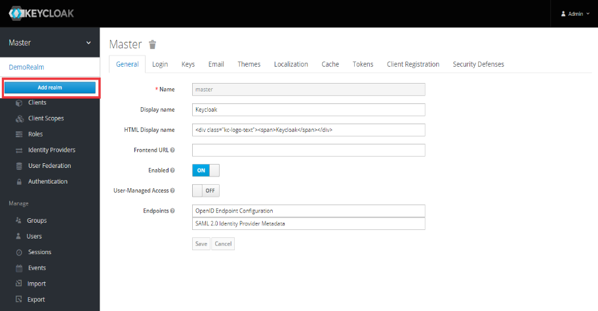
- Create a customized Realm in keycloak by clicking on Add Realm as shown in below

- Create a Realm “Arc” and make sure Enabled will be ON and click on create as shown in below [Realm name can be anything, but needs to be same while configuring in the services]
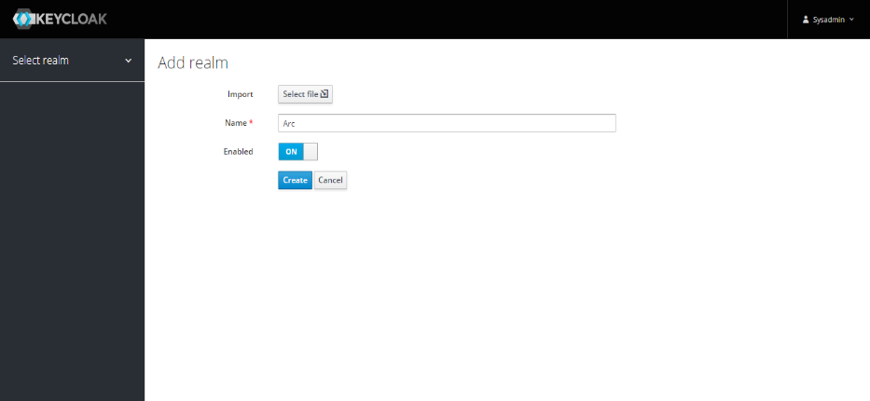

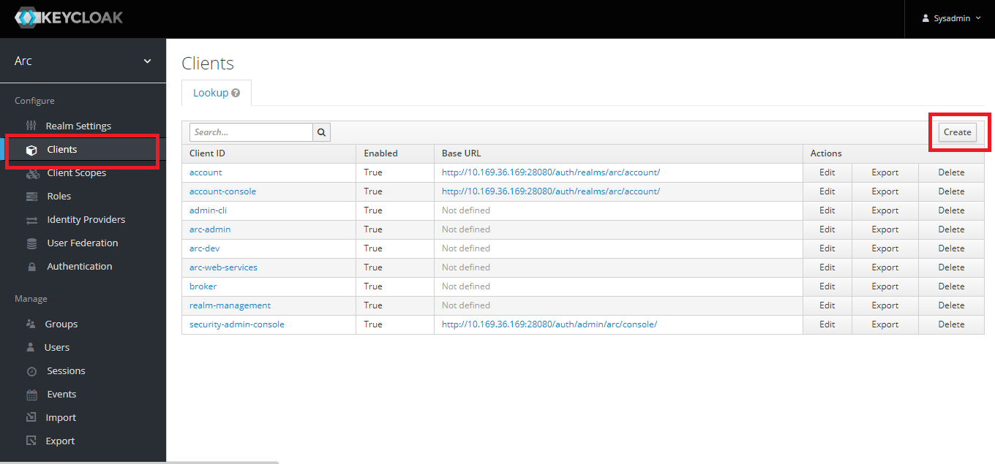
- Click on Clients to configure client for the realm “arc-client” (created previously) in keycloak and click on create to create as shown in below

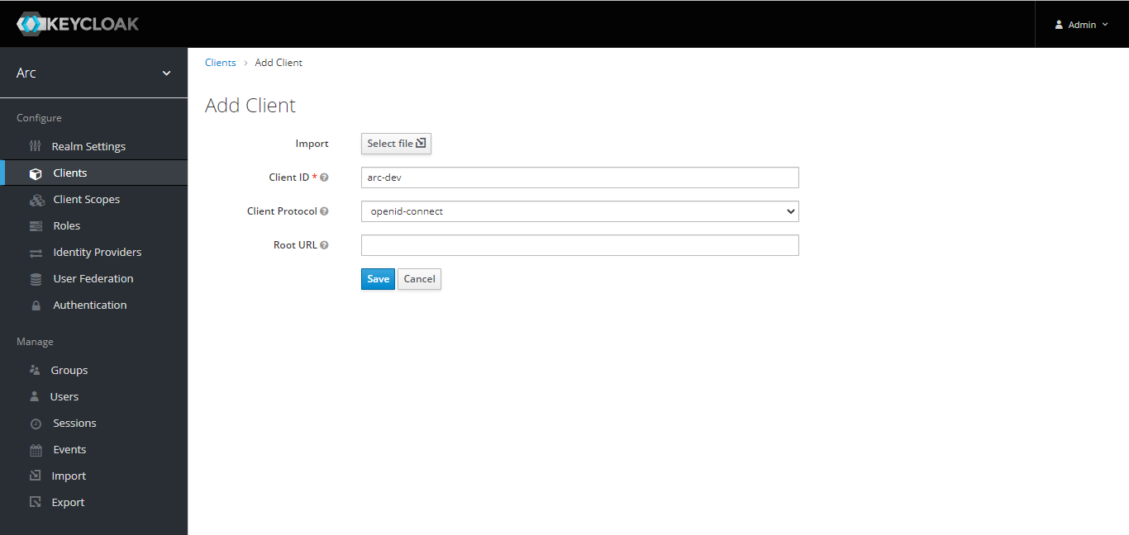
- Create Client Id “arc-client” and select openid-connect as client protocol as shown in below

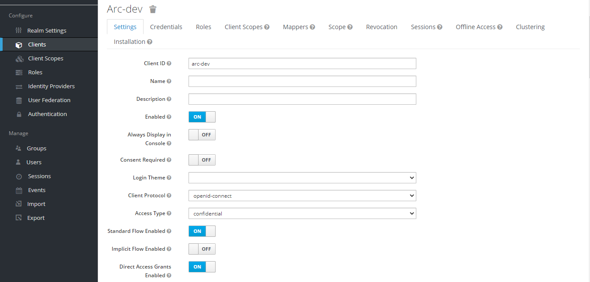
- After creating client Id, Client has below configuration for “Settings” and modify according by referring the below attachments (I to V) step by step and click on save.

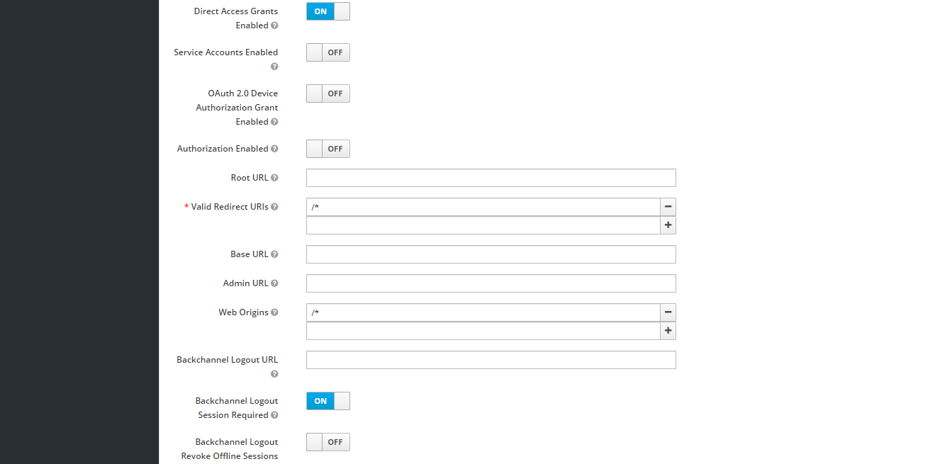
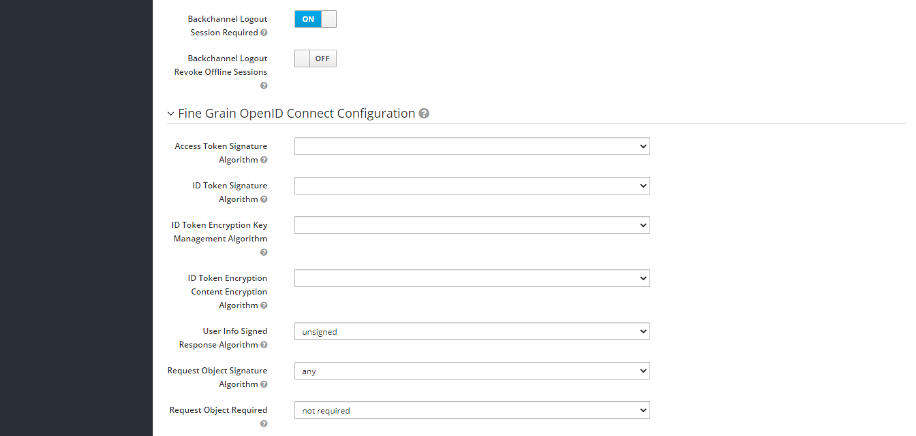
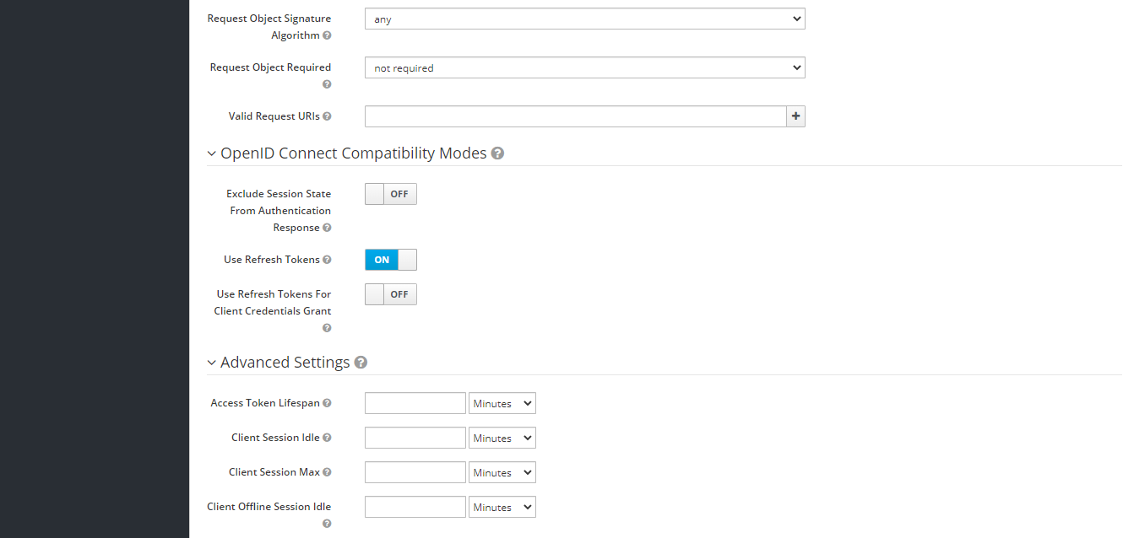

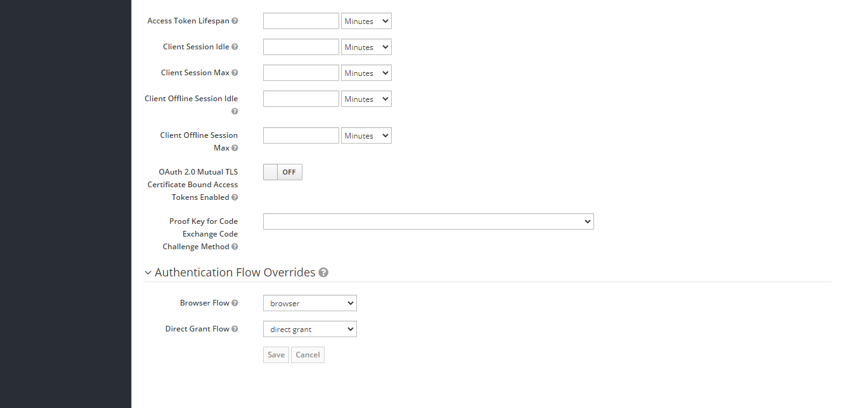
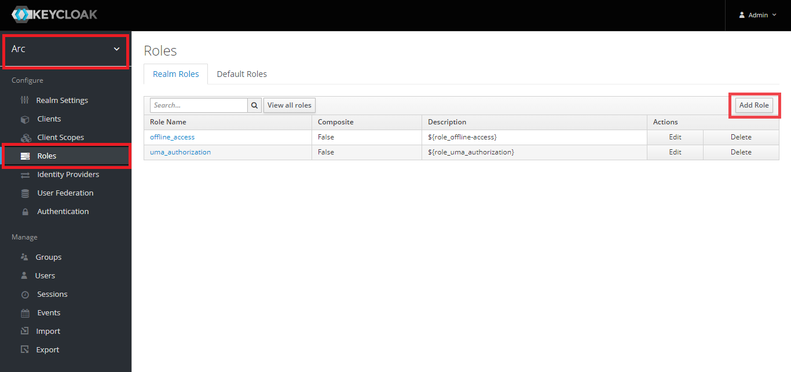
- After configuring, Click on Roles from Left side configuration to add various roles for ARC as shown in below (Make sure adding roles for the same realm which was created previously)

- Add the “compliance_lead” role and click on save by referring the below Image
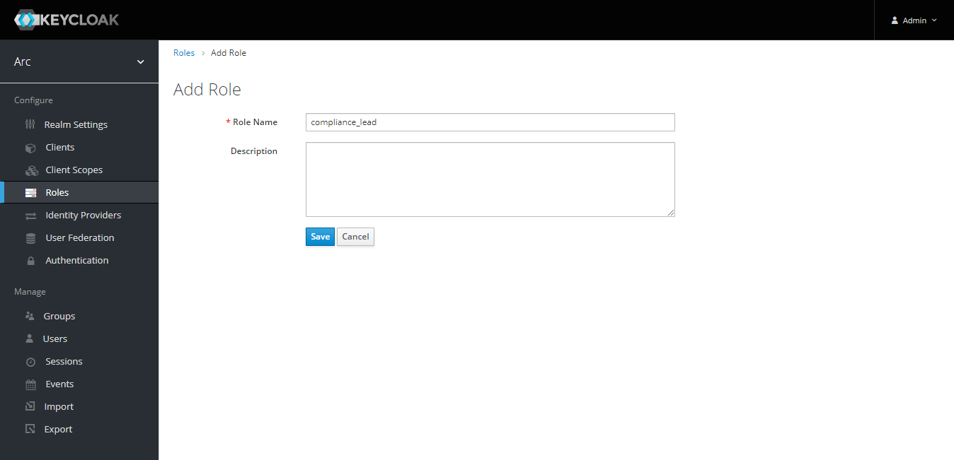
- (Similarly add the below mentioned roles) by repeating the same steps for different roles as below
- admin
- chief_compliance_officer
- chief_risk_officer
- compliance_analyst
- compliance_lead [Added previously as shown In snapshot]
- legal_analyst
Description is optional. [Make sure all mentioned above roles are added successfully]
- Make sure above mentioned Roles are available in Roles → Realm Roles → View All Roles
- To add Users to access ARC, Refer Users → “Add user” as shown in below and to view the users after creation click on “View all users”.
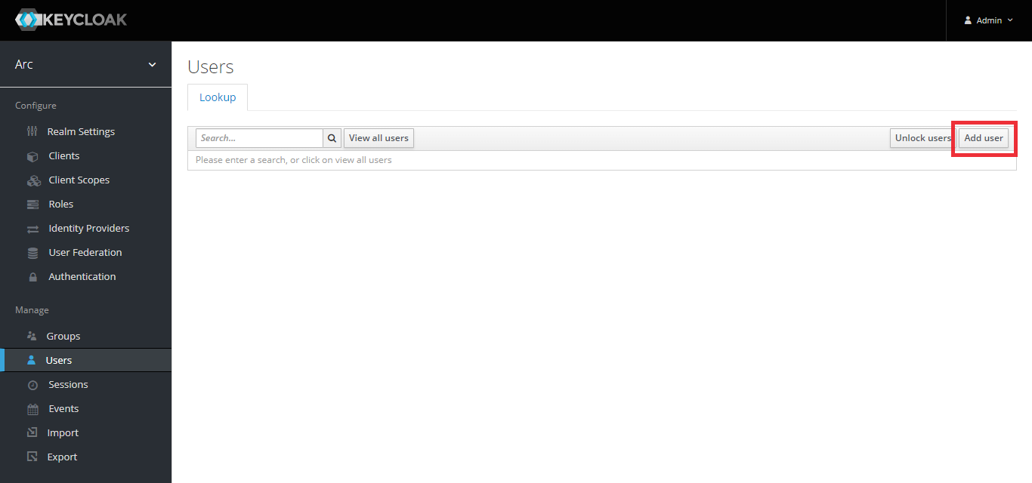
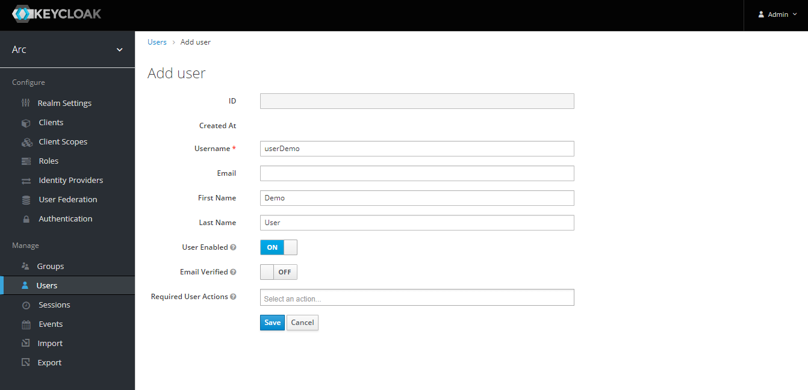
- Add the users by referring the below attachment [Here adding the UserDemo as a user as an example, similarly, can add for other users as well by following the same steps] and click on save.

- Create the password for above created user as shown in below. [Go to Credentials to create password after successful of user creation.] and click on set password.

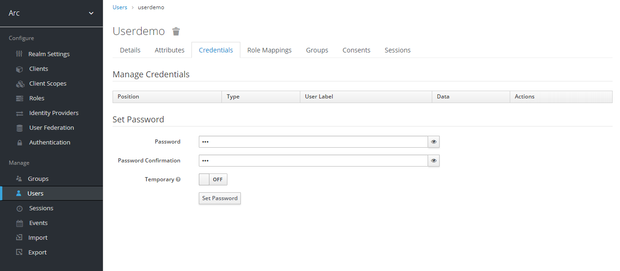
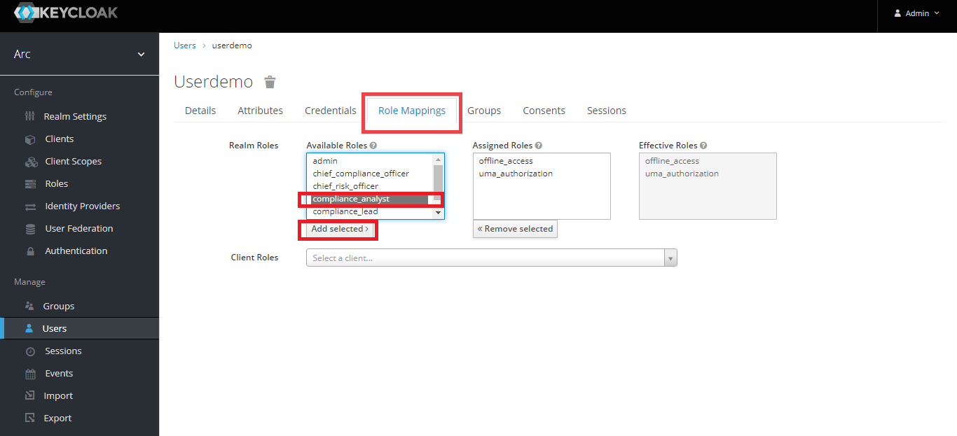
- To Map role to the above created role, refer as shown in below [Mapping compliance_analyst role to the user]

- For ARC, It is mandatory to create one user with below credentials for realm-admin access in client Roles in keycloak.
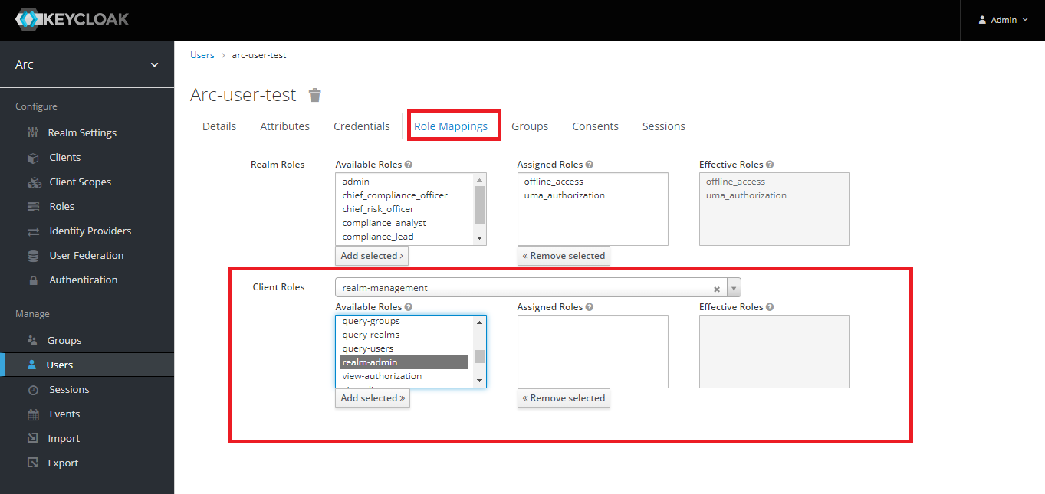
→ Username : arc-user-test and Password : tcs [Credentials can be changed but same need to be configured in yml files for arc-uam service] and have to add realm-admin in realm management role mapping in keycloak as shown in below. For this user no need to map any Realm Roles.

- After creation of user and role mappings, Need to assign attribute for each role except realm admin user [arc-user-test] as shown in below. Attribute can be Employee Id, Customer Id, Product Id etc..[By default, the value will be user name]. Make sure key will be same as below attachment.
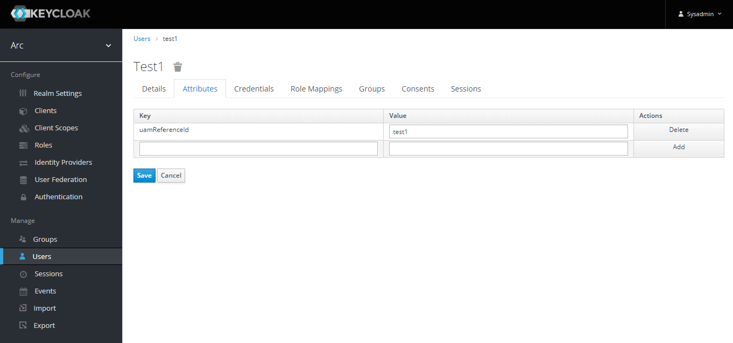

- To configure arc uam service, need client credential, Same can be fetch from
clients → credentials → Secret [Copy and paste in yml file of uam service]
- To configure keycloak URL's in arc-uam service can be fetch from
Realm Settings → General → OpenId Endpoint Configuration → copy the required URL's.
[token_endpoint, introspection_endpoint, end_session_endpoint, generateAccessTokenUrl and LogoutUrl]
- To configure Token session Time Management, Refer the following path
Realm Settings → Tokens [To specify life span of access Token and session time out]
Default Algorithm Signature will be “RS256”.
- Usually 45 min will be access Token life span and may vary according to the requirements,
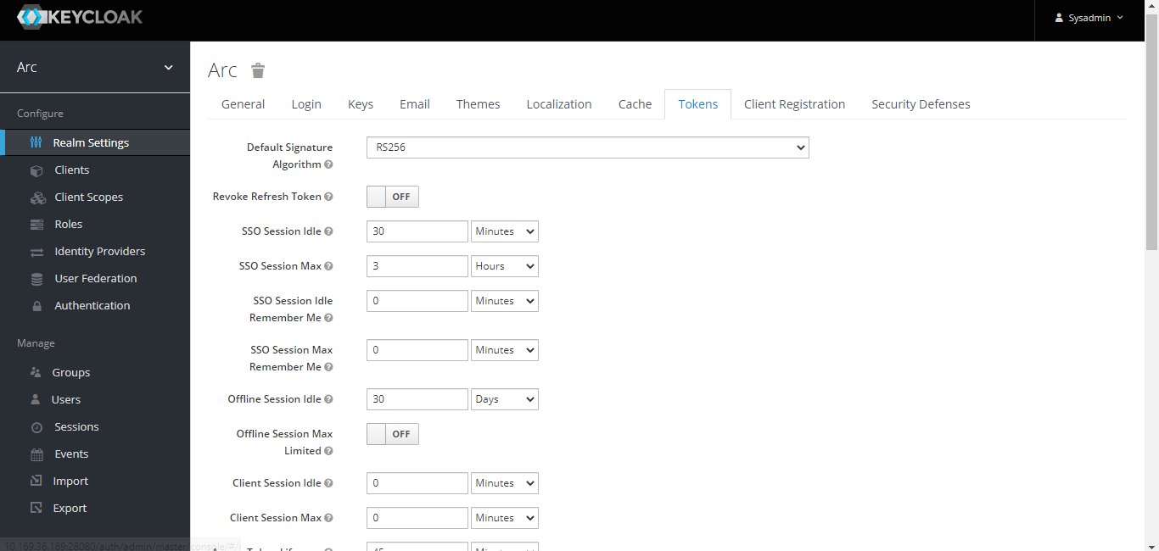
- Please refer below attachments for sample settings
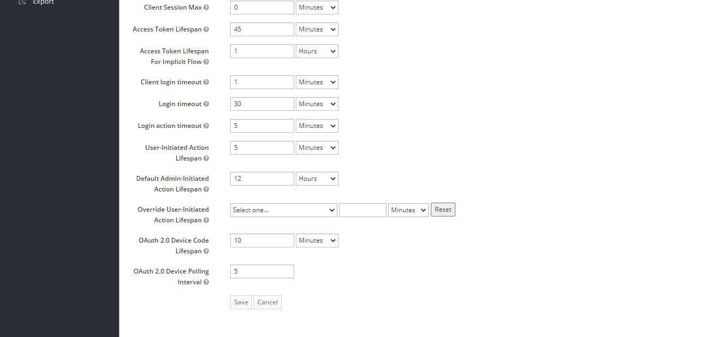

- Legal Analyst users which is mandatory [For each risktheme mapping 1 legal Anlayst]
and create atleast one user for each role

- Verify the Users in Roles in this path ->
Configure -> Roles -> respective_role-> Users in Role

- Installation Procedure
  - DB Setup
- Create a database by name “arc”
- Run the script file “arc-db-scripts.sql”

  - Keystore setup
- Install keystore file provided in one of the directories and copy
Ex: /data/applications/arc/keystore/keyStore.keystore
To get new keystore file, Run the program provided by using AES algorithm with keystore set entry will be “idEncryptionKey” and password will be changeit [change as per policy]

  - Update config files
  - In each of “.yml” the below configuration needs to be placed
keystoreFolder: /data/applications/arc/keystore/keyStore.keystore [depending up-on path]
keyStorePassword : changeit [change as per policy]

  - Database details needs to be configured with schema provided
ipaddress: PostgreSQL IP address
port: PostgreSQL port
DB_NAME: ARC database name
SCHEMA_NAME: ARC schema created
Ex: driverClassName: org.postgresql.Driver
url: jdbc:postgresql://ipaddress:port/DB_NAME?currentSchema=SCHEMA_NAME
username: i9D9V0YktOheYgTITPmpRdXjOKBNWGwD9I65xoxcVTPQOIo=
dbPassword: gx9RO+po7c8+5qnyvKQCIzukHzOk6pFp8MdHcyuv+iyhwA==
[username and dbPassword is encrypted. Use encryption Jar]

- arc-discovery-server [if any change in port number of this service, same needs to be updated in all other yml files]
# Discovery Server Access
eureka:
client:
serviceUrl:
defaultZone: http://localhost:21000/eureka/
registryFetchIntervalSeconds: 20
instance:
hostname: localhost

- Any change in arc-uam service port should be updated in “yml” files of
arc-console-application.yml
arc-ontology-application.yml
arc-api-gateway-application.yml
Also, change the IP address pointing to arc-uam server IP
IPaddress: arc-uam server IP
Port: arc-uam service port (can be fetched from arc-uam-application.yml)
getUserList: http://IPaddress:Port/getUserDetails
getKeycloakAdmins: http://IPaddress:Port/getKeycloakAdmins
getAccessToken: http://IPaddress:Port/getAccessToken
getUserName: http://IPaddress:Port/getUserName

- Python services URL’s in arc-console-application.yml configuration
IPaddress: arc-python-ipaddress
Port: arc-python-port (should be httpd port where python services are configured)
extractPdfUrl: http://IPaddress:Port/extractpdf
genArtifactUrl: http://IPaddress:Port/genartifact
getGenArtifactResultUrl: http://IPaddress:Port/reqfile
fileDownloadStatusUrl: http://IPaddress:Port/downloadfilestatus
generateGraphUrl: http://IPaddress:Port/creategraph
artifactStatusUrl: http://IPaddress:Port/genartifact/status
getPdfPageSizeUrl: http://IPaddress:Port/pdfpagecount

- Python services URL’s in arc-ontology-application.yml configuration
IPaddress: arc-python-ipaddress
Port: arc-python-port (should be httpd port where python services are configured)

extractPdfUrl: http://IPaddress:Port/extractpdf
genArtifactUrl: http://IPaddress:Port/genartifact
generateGraphUrl: http://IPaddress:Port/creategraph
similarMentionUrl: http://IPaddress:Port/synonymsFinder
topRankSenteceUrl: http://IPaddress:Port/topranksent
conceptPathUrl: http://IPaddress:Port/conceptpath

- Scheduler services calling in arc-console-application.yml configuration:
IPaddress: arc-scheduler-service-ipaddress
Port: arc-scheduler-service-port (can be fetched from arc-scheduler-application.properties)
schedulingJobUrl: http://IPaddress:Port/schedulingJob
deleteScheduleUrl: http://IPaddress:Port/deleteJobs
getScheduleUrl: http://IPaddress:Port/getScheduleJobs

- Ontology services calling in arc-console-application.yml configuration:
IPaddress: arc-ontology-ipaddress
Port: arc-ontology-port (can be fetched from arc-ontology-application.yml)

evictSentenceCacheUrl: http://IPaddress:Port/evictSentenceCache

- UAM services calling in arc-api-gateway-application.yml configuration:
IPaddress: arc-uam-ipaddress
Port: arc-uam-port (can be fetched from arc-uam-application.yml)
uamLogoutApiUrl : http://IPaddress:Port/logoutUserSession
getAccessTokenURL: http://IPaddress:Port/getAccessTokenLogin
getUserByRoleMap: http://IPaddress:Port/getUserByRoleMap
getUserReferenceId: http://IPaddress:Port/getUserReferenceId

  - Install UI Module
- Modify/add in httpd.conf

RewriteEngine On
RewriteCond %{REQUEST_METHOD} ^(TRACE|TRACK)
RewriteRule .* - [F]
RewriteCond %{HTTPS} off
RewriteRule (.*) https://%{HTTP_HOST}%{REQUEST_URI} [R=301,L]

<VirtualHost ipaddress:port>
ServerName ipaddress
SSLEngine on
SSLCipherSuite ALL:!aNULL:!ADH:!eNULL:!LOW:!EXP:!NULL:!RC4:!RC2:!DES:!3DES:!SHA:!SHA256:!SHA384:!MD5+HIGH:+MEDIUM
SSLCertificateFile /localpath/apache-selfsigned.crt
SSLCertificateKeyFile /localpath/apache-selfsigned.key
ErrorLog path_for_error_file
CustomLog localpath/arc-access_log common]

ErrorDocument 404 /errors/404.html
ErrorDocument 500 /errors/50x.html
ErrorDocument 502 /errors/50x.html
ErrorDocument 503 /errors/50x.html
ErrorDocument 504 /errors/50x.html

DocumentRoot /localpath/ARC

<Directory "/localpath/ARC">
Options Indexes FollowSymLinks
AllowOverride None
Require all granted
RewriteBase /ARC
RewriteRule ^index\.html$ - [L]
RewriteCond %{REQUEST_FILENAME} !-f
RewriteCond %{REQUEST_FILENAME} !-d
RewriteCond %{REQUEST_FILENAME} !-l
</Directory>

ServerPath /ARC
ProxyPass /errors !
ProxyErrorOverride On
ProxyPass /arc/login http://api_gateway_ipaddress:api_gateway_port/login retry=0
ProxyPass /api/arc http://api_gateway_ipaddress:api_gateway_port/api/arc retry=0
ProxyPass /arc/logOut http://api_gateway_ipaddress:api_gateway_port/logOut retry=0

ProxyRequests Off
ProxyPreserveHost On
AllowEncodedSlashes NoDecode

ProxyPassReverse /arc/login http://api_gateway_ipaddress:api_gateway_port/login
ProxyPassReverse /arc/logOut http://api_gateway_ipaddress:api_gateway_port/logOut
ProxyPassReverse /api/arc http://api_gateway_ipaddress:api_gateway_port/api/arc
</VirtualHost>
  - Install Python services

- Un-Installation Procedure
- Uninstall Core services by killing the process of corresponding jar file using respective process id.
- Uninstall UI-Module by removing the build folder from the deployed server.
- Uninstall Cognitive services by stopping the execution of httpd.exe from Apache Httpd server.



About Tata Consultancy Services Ltd (TCS)
Tata Consultancy Services is an IT services, consulting and business solutions organization that delivers real results to global business, ensuring a level of certainty no other firm can match. TCS offers a consulting-led, integrated portfolio of IT and IT-enabled infrastructure, engineering and assurance services. This is delivered through its unique Global Network Delivery Model TM, recognized as the benchmark of excellence in software development. A part of the Tata Group, India’s largest industrial conglomerate, TCS has a global footprint and is listed on the National Stock Exchange and Bombay Stock Exchange in India.
For more information, visit us at www.tcs.com.

IT Services
Business Solutions
Outsourcing

All content/information present here is the exclusive property of Tata Consultancy Services Limited (TCS). The content/information contained here is correct at the time of publishing. No material from here may be copied, modified, reproduced, republished, uploaded, transmitted, posted or distributed in any form without prior written permission from TCS. Unauthorized use of the content/information appearing here may violate copyright, trademark and other applicable laws, and could result in criminal or civil penalties. Copyright © 2014 Tata Consultancy Services Limited

